**Functional Requirements of Resource Management**

**Coordinator/ User :-**

1. **Login**

The member logins to the website using the assigned id and password. If the member logins successfully then they are taken to the Dashboard where they can see the resource details and perform required actions

1. **Manage Resources**

The coordinates/members can view available, allocated, and list of all the resources in the organization. Further, they can manage their booked resource i.e. viewing resource description, time duration, requirements, attendance, feedback and certification by entering into respective tabs in the dashboard

**Features Supported in the Website**

**Functions available for Coordinators/Members are as follows:**

1. View available resources
2. View booked resources
3. View allocated resources
4. View available resources
5. View conducted resources
6. Book resources(Requesting the resource)

**Workflow of Coordinators/Members**

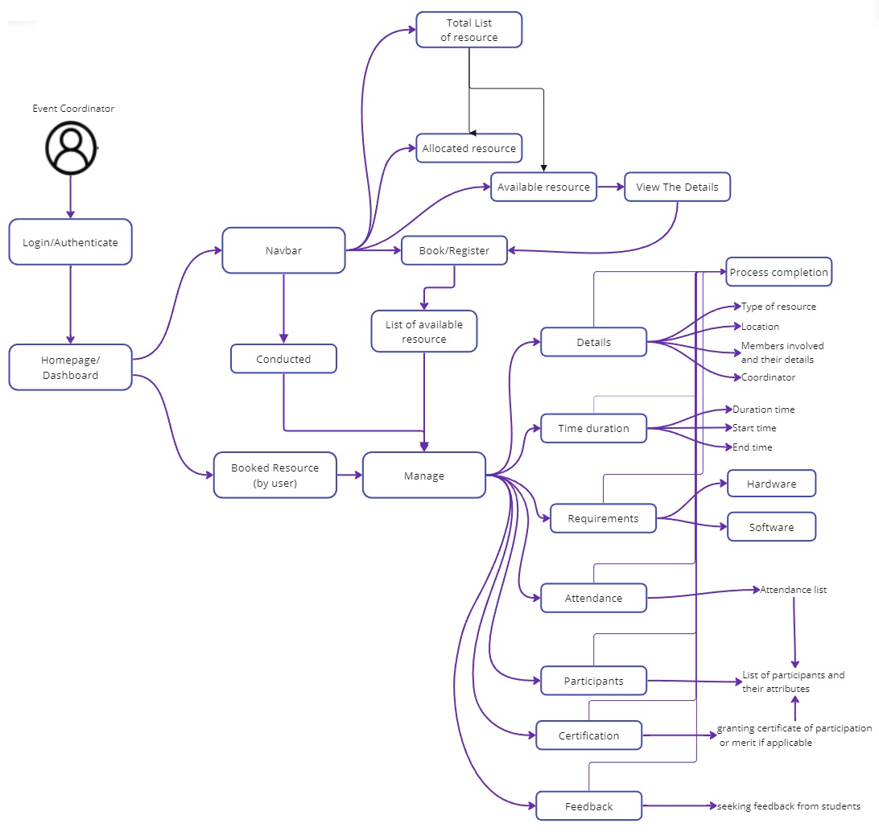

*Login > Dashboard > Booked Resources > Manage Resources*

*Login > Dashboard > Book/Register*

*Login > Dashboard > Available Resources > View Details > Book/Register*

*Login > Dashboard > Allocated Resources > View Details*

*Login > Dashboard > Conducted Resources > Manage/Access Details*

On the **Coordinator Dashboard interface**, a list of all Booked resources maintained by the logged-in user is displayed. View a resource complete information, additional options are provided.

|  |  |
| --- | --- |
| Dashboard | Allows the user to select either booked/available/allocated resources |
| Resource List | List of all resources and its details/attributes |
| Resource Name | Name and type of resource |
| Location | Location of resource |
| Members | List of members/volunteers and their details |
| Coordinator | Coordinator managing the event |
| Time duration | Total time, start time, end time , time left |
| Requirements | Hardware and software specifications and requirements |
| Attendance | Attendance list |
| Participants | list of participants and their details |
| Certification | Certification approvals for the participants |

**To Manage Resources**

1. In the Dashboard field, list of all booked resources appear

Click Manage to view Resource description, time duration, requirements, participants, etc

1. In the Dashboard field, Click Book to register the resource and provide the required details.
2. In the Dashboard field, Click Available Resources. List of all free and available resources shows up. Click Book to register the resource and provide the required details.
3. In the Dashboard field, Click Allocated Resources. List of all allocated resources shows up to view details.
4. In the Dashboard field, Click Available Resources. List of all free and available resources shows up. Click Book to register the resource and provide the required details.
5. Click Back to Dashboard to navigate back to the dashboard.

**Admin:-**

1. **Login/ Authenticate**

The admin logins to the website using the authorized id and password. If the admin logins successfully then they are taken to the Dashboard where they can see the resource details, coordinator details and perform required actions.

1. **Manage Resources**

The admin can view available, allocated, and list of all the resources in the organization and its detailed descriptions. Further, Admin can view list of coordinators active and can add or delete them. Admin can see resource request in notification panel.

**Features Supported in the Website**

**Functions available for Admin are as follows:**

1. Resource Panel
   * View available resources
   * View allocated resources
   * View available resources
   * View conducted resources
2. Coordinator Panel
   * View coordinator list
   * Add coordinator
   * Delete coordinator
3. Notifications Panel
   * View Details
   * Fulfil hardware / software requirements
   * Approve request
   * Deny request

**Workflow of Admin**

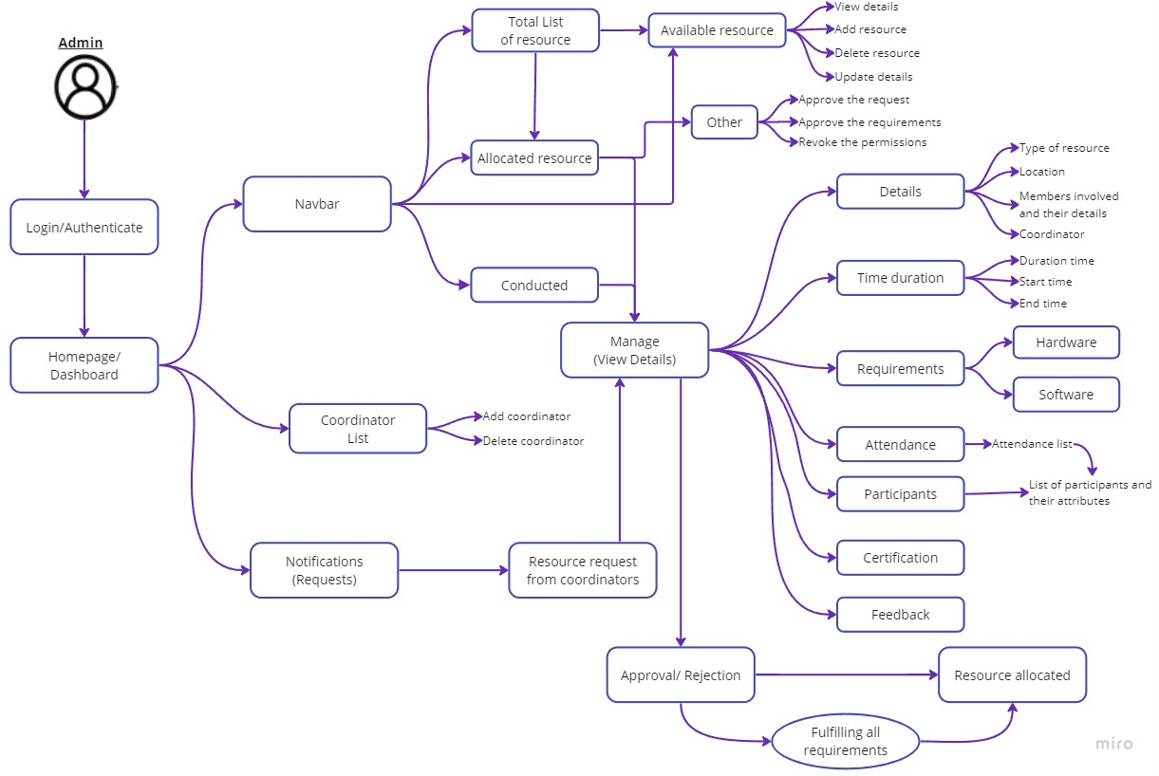

*Login > Dashboard > Coordinator List > Add coordinator*

*Login > Dashboard > Coordinator List > Delete coordinator*

*Login > Navbar > Available Resources > Update details*

*Login > Navbar > Available Resources > View details*

*Login > Navbar > Available Resources > Add resource*

*Login > Navbar > Available Resources > Delete resource*

*Login > Navbar > Available Resources > Update details*

*Login > Navbar > Allocated Resources > Other > Approve requests*

*Login > Navbar > Allocated Resources > Other > Approve requirements*

*Login > Navbar > Allocated Resources > Other > Revoke permissions*

*Login > Navbar > Allocated Resources > View Details*

*Login > Navbar > Conducted Resources > View Details*

*Login > Notifications > Resource details > Approve requests*

*Login > Notifications > Resource details > Deny requests*

On the **Admin Dashboard interface**, a list of all coordinators, navbar with all other options and notifications panel is displayed.

|  |  |
| --- | --- |
| Dashboard | List of all coordinators, navbar with all other options and notifications panel |
| Coordinator List | List of all Coordinator and their details and options to add/delete coordinator |
| Navbar | Contains options:- available, allocated, conducted resources |
| Resource List | List of all resources and its details/attributes |
| Resource Name | Name and type of resource |
| Location | Location of resource |
| Members | List of members/volunteers and their details |
| Coordinator | Coordinator managing the event |
| Time duration | Total time, start time, end time , time left |
| Requirements | Hardware and software specifications and requirements |
| Attendance | Attendance list |
| Participants | list of participants and their details |
| Certification | Certification approvals for the participants |
| Notifications | All resource requests, its details, Approve/Deny request |

**To Manage Resources**

1. In the Dashboard field, list of all booked resources appear

Click Manage to view Resource description, time duration, requirements, participants, etc

1. In the Dashboard field, Click Book to register the resource and provide the required details.
2. In the Dashboard field, Click Available Resources. List of all free and available resources shows up. Click Book to register the resource and provide the required details.
3. In the Dashboard field, Click Allocated Resources. List of all allocated resources shows up to view details.
4. In the Dashboard field, Click Available Resources. List of all free and available resources shows up. Click Book to register the resource and provide the required details.
5. Click Back to Dashboard to navigate back to the dashboard.